## 结果截图

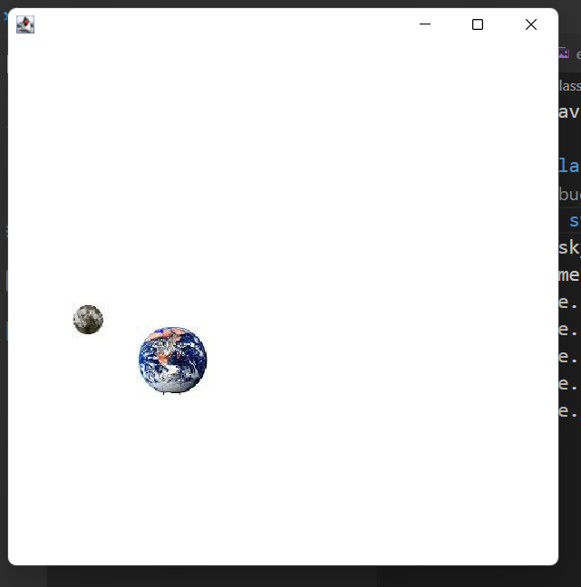

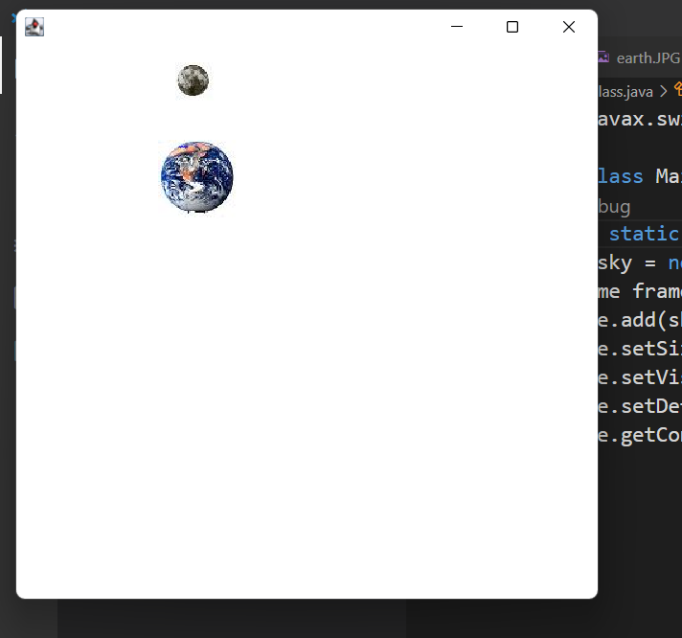

## 代码截图

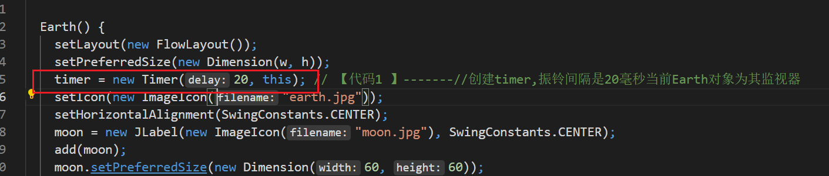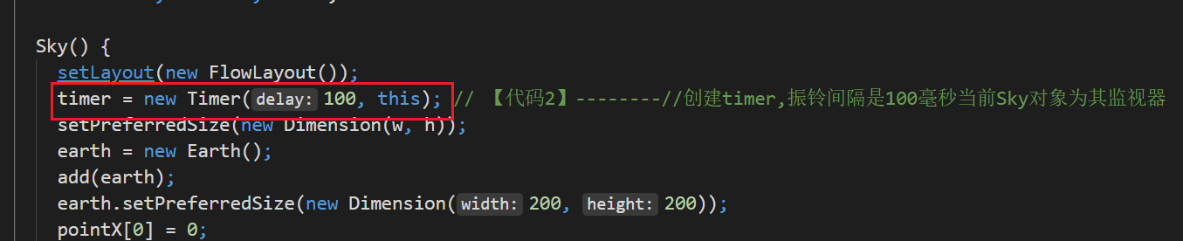

## 源码

import javax.swing.*;

public class MainClass {

public static void main(String args[]) {

Sky sky = new Sky();

JFrame frame = new JFrame();

frame.add(sky);

frame.setSize(500, 500);

frame.setVisible(true);

frame.setDefaultCloseOperation(JFrame.EXIT_ON_CLOSE);

frame.getContentPane().setBackground(java.awt.Color.white);

}

}

//

import java.awt.*;

import javax.swing.*;

import java.awt.event.*;

public class Earth extends JLabel implements ActionListener {

JLabel moon; // 显示月亮之外观

Timer timer;

double pointX[] = new double[360],

pointY[] = new double[360];

int w = 200, h = 200, i = 0;

Earth() {

setLayout(new FlowLayout());

setPreferredSize(new Dimension(w, h));

timer = new Timer(20, this); // 【代码1 】-------//创建timer,振铃间隔是20毫秒当前Earth对象为其监视器

setIcon(new ImageIcon("earth.jpg"));

setHorizontalAlignment(SwingConstants.CENTER);

moon = new JLabel(new ImageIcon("moon.jpg"), SwingConstants.CENTER);

add(moon);

moon.setPreferredSize(new Dimension(60, 60));

pointX[0] = 0;

pointY[0] = h / 2;

double angle = 1 * Math.PI / 180; // 刻度为1度

for (int i = 0; i < 359; i++) { // 计算出数组中各个元素的值

pointX[i + 1] = pointX[i] * Math.cos(angle) - Math.sin(angle) * pointY[i];

pointY[i + 1] = pointY[i] * Math.cos(angle) + pointX[i] * Math.sin(angle);

}

for (int i = 0; i < 360; i++) {

pointX[i] = 0.8 * pointX[i] + w / 2; // 坐标缩放、平移

pointY[i] = 0.8 * pointY[i] + h / 2;

}

timer.start();

}

public void actionPerformed(ActionEvent e) {

i = (i + 1) % 360;

moon.setLocation((int) pointX[i] - 30, (int) pointY[i] - 30);

}

}

//

import java.awt.*;

import javax.swing.*;

import java.awt.event.*;

public class Sky extends JLabel implements ActionListener {

Earth earth;

Timer timer;

double pointX[] = new double[360],

pointY[] = new double[360];

int w = 400, h = 400, i = 0;

Sky() {

setLayout(new FlowLayout());

timer = new Timer(100, this); // 【代码2】--------//创建timer,振铃间隔是100毫秒当前Sky对象为其监视器

setPreferredSize(new Dimension(w, h));

earth = new Earth();

add(earth);

earth.setPreferredSize(new Dimension(200, 200));

pointX[0] = 0;

pointY[0] = h / 2;

double angle = 1 * Math.PI / 180; // 刻度为1度

for (int i = 0; i < 359; i++) { // 计算出数组中各个元素的值

pointX[i + 1] = pointX[i] * Math.cos(angle) - Math.sin(angle) * pointY[i];

pointY[i + 1] = pointY[i] * Math.cos(angle) + pointX[i] * Math.sin(angle);

}

for (int i = 0; i < 360; i++) {

pointX[i] = 0.5 * pointX[i] + w / 2; // 坐标缩放、平移

pointY[i] = 0.5 * pointY[i] + h / 2;

}

timer.start();

}

public void actionPerformed(ActionEvent e) {

i = (i + 1) % 360;

earth.setLocation((int) pointX[i] - 100, (int) pointY[i] - 100);

}

}